“What we…learn to do, we learn by doing” -Aristotle


This Implementation Plan will help you to practice (USING THE SKILLS AND KNOWLEDGE WE DISCUSSED) in the training. It is important to try out the things you have learned in the training so you can really understand them. The trainer will read this Implementation Plan and give you some more ideas for ways that you can do even better in the future.

The Core Competency this Implementation Plan addresses is:

DIRECTIONS:
- Give Step-By-Step instructions
- Separate out each individual point
- Try to ensure that you do not have multiple directions on a single line
- Keep each direction clear and simple
- Use short sentences and simple language
- Define technical terms, even if they were part of the training
- Directions can be quite long, but practitioners often need the help to stay organized

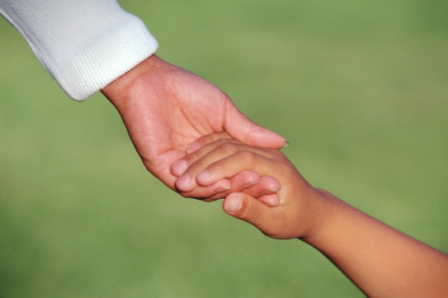
Teacher’s Explanation of Activity:
Explaining what was done

It is important for the trainer to understand exactly what you did. This will help the trainer give you some ideas to do an even better job next time.

- How did you (perform the skills of the IP)?

- What area of the classroom did you change?

- What materials did you use?

- What words did you use when you (performed the skills of the IP)? Please write at least 3 quotes that you said.


ANECDOTAL NOTES:
Describing the results

To really understand what happened, to learn from it, and to grow, it is important to know exactly what happened. It is important to be clear and to write only what happened. Later, there will be questions that will help you talk about how you felt about what happened. For now, try to only write exactly what happened.

1. Where were the children when you watched them (the block area, the playground, etc.)?

2. How many children were playing in that area?

3. What materials or toys did the children use?

4. What did the children do with these materials?

5. What did the children do when you (performed the skills of the IP)?

6. What did the children say when you (performed the skills of the IP)? Please write at least 3 quotes that the children said.


THE ARTIFACT:
Showing your work

A really important part of learning is showing other people what you did and what you learned. This helps you to see your work and to think about everything you learned.

1. Please take a photograph of the children before (you performed the skills of the IP)?
2. Label the back of the photograph with your name and the word “Before”.
3. Take another photograph of the children after you (performed the skills of the IP)?
4. Label the back of this photograph with your name and the word, “After”.
5. Place these photographs in zip-top plastic bags and attach them here:

ATTACH PHOTOGRAPHS HERE

Please label all pictures

Please attach photo release forms for all children pictured

REFLECTION:

Looking back to move forward

To truly learn anything, you have to reflect and think about what you learned. Please take some time to consider the following questions and write your thoughts here.

- Why is it important to (perform the skills of the IP)?

- What was difficult about (performing the skills of the IP)?

- What did you like about using (performing the skills of the IP)?

- Will you continue to (perform the skills of the IP) in the future? Why or why not?

- What could you do next time to (perform the skills of the IP) even better?

- What did you learn about teaching young children when you (performed the skills of the IP)?

DIRECTOR’S SIGNATURE________________________________________ Date__________
TEACHER SIGNATURE ___________________________________________Date_________


TRAINER COMMENTS:
Feedback to help you

The trainer is your partner in learning. The comments will help you think of ways to become an even better teacher. The trainer is always available for help and support!

 | EXCELLENT  5 | STRONG  4 | GOOD  3 | FAIR  2 | POOR  1
Teacher Explanation of Activity
Design and Implementation of Activity
Artifacts and Anecdotal Notes
Teacher Reflection
Rubric Key:
5- Excellent- The section exceeds all of the criteria
4- Strong- the section meets all of the criteria
3- Good- the section meets most of the criteria
2- Fair- the section does not meet most of the criteria- Please correct and resubmit IP
1- Poor- the section does not meet any of the criteria- Please correct and resubmit IP

Additional Comments:

Trainer Signature___________________________ Score_______

