How to Process a P-Card Transaction

P-Card transactions appear in PantherNet within 3-5 days of the purchase. Cardholders should process their transaction(s) and send for approval within 3 business days of the purchase appearing in the system.

- Use the path CM PC BA, enter S to select the cardholder as shown below. (ENTER)
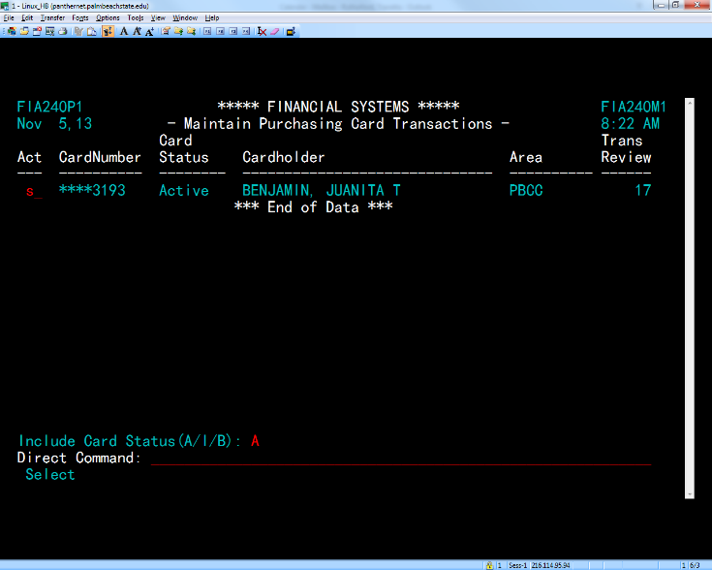

- All transactions for cardholder will appear. Enter M to modify transactions. (ENTER)

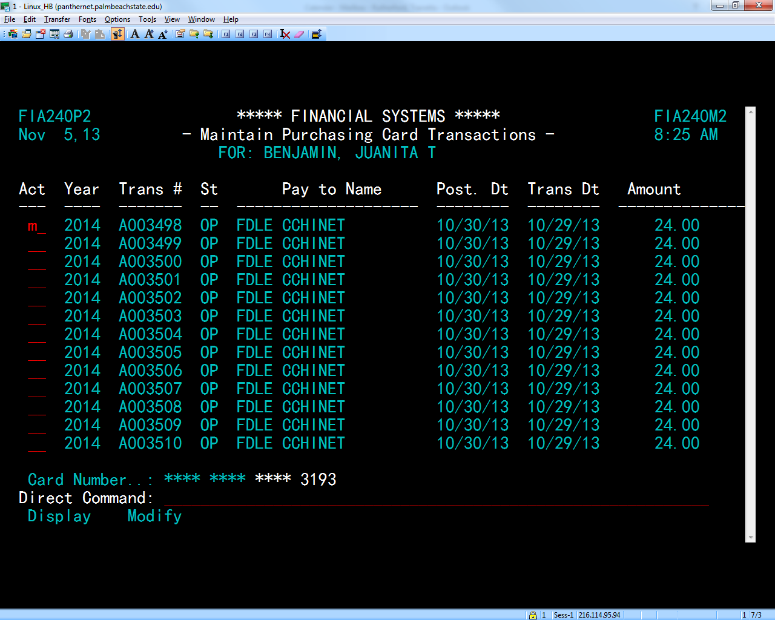

- Check the vendor ID field to see if it automatically populated. If not, search the list of vendors by pressing (F1). Type in a portion of the vendor name and press enter. Cursor up to vendor name and press enter to populate the vendor field. Leave blank if vendor cannot be located on the file list.

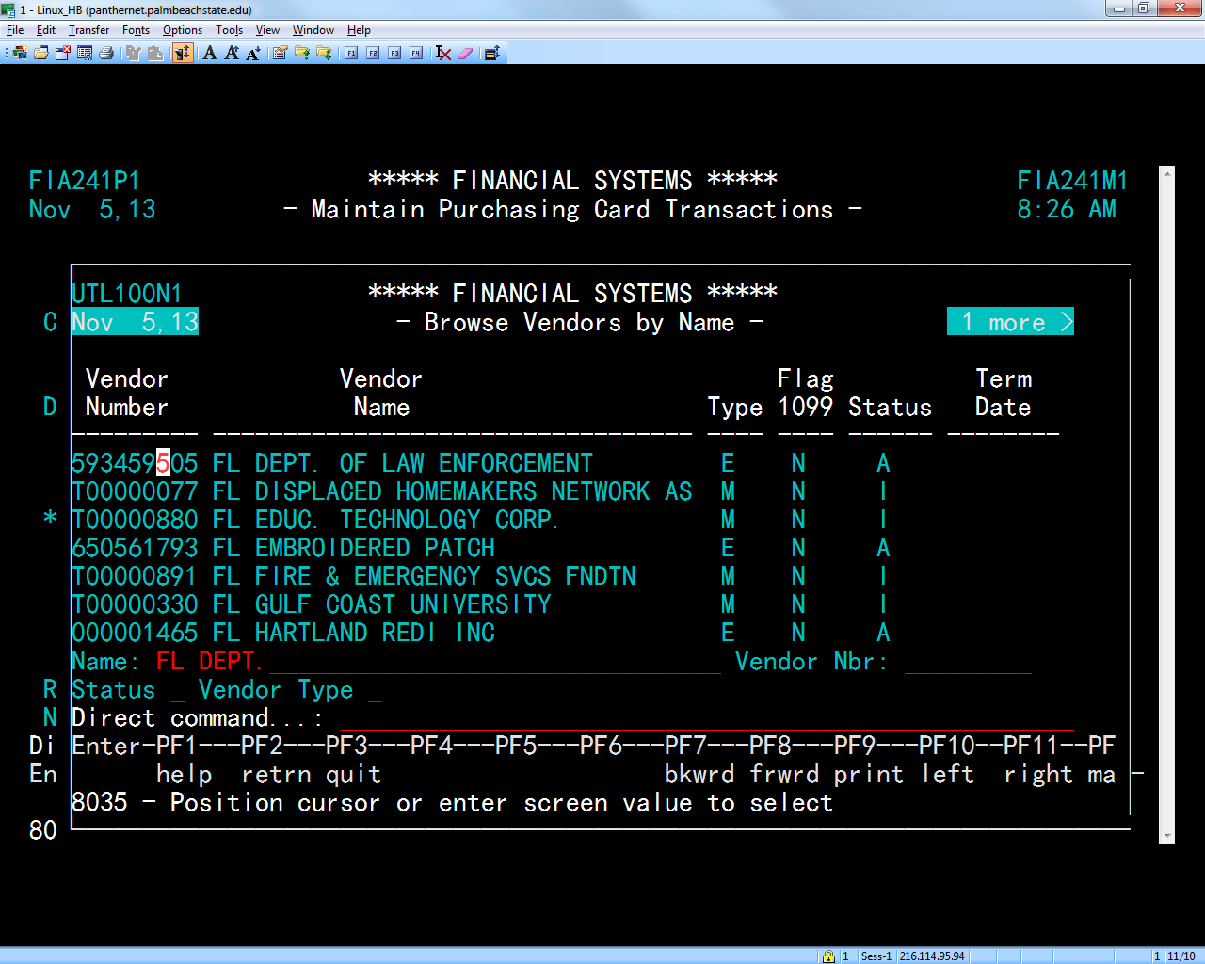

Type Vendor Name here

- In the description field write: What was purchased and for what purpose the item was used. For travel related transactions: Purpose, city, and dates of travel. Include as much information as possible

- Assign the appropriate Org unit number(s) and general ledger (GL) code(s) to the P-Card transaction. Always verify this field. (ENTER)

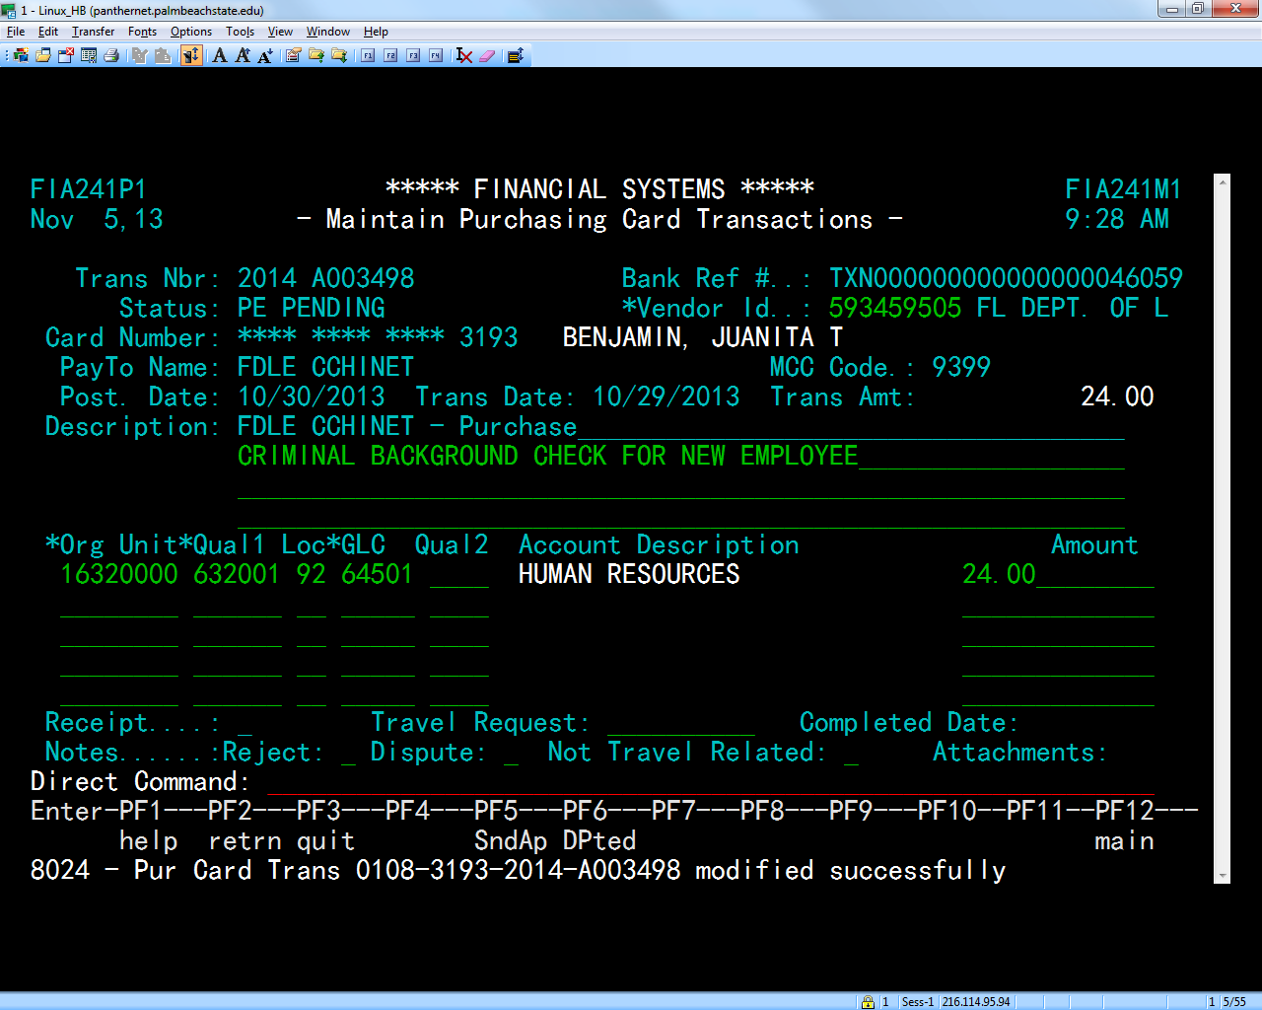

- To send for approval press (F5), type the word yes, and press Enter.

- It is the cardholder’s responsibility to make sure the transaction has made it through the approval process and gets to the Finance Department (P-Card Specialist’s PantherNet Approval Queue) within one week of the transaction being loaded into PantherNet.

Tips:
To see all P-Card transactions made by a particular cardholder, use the path CM PC PS
To locate a P-Card transaction in the approval path, use CM AS DQ
*System Id: FIA
*Document Type: PC
Document ID: 2014A003498 (ENTER)

